Cloud mqtt account:

<https://www.cloudmqtt.com/>

[vutgeanh98@gmail.com](mailto:vutgeanh98@gmail.com)

09220805070602

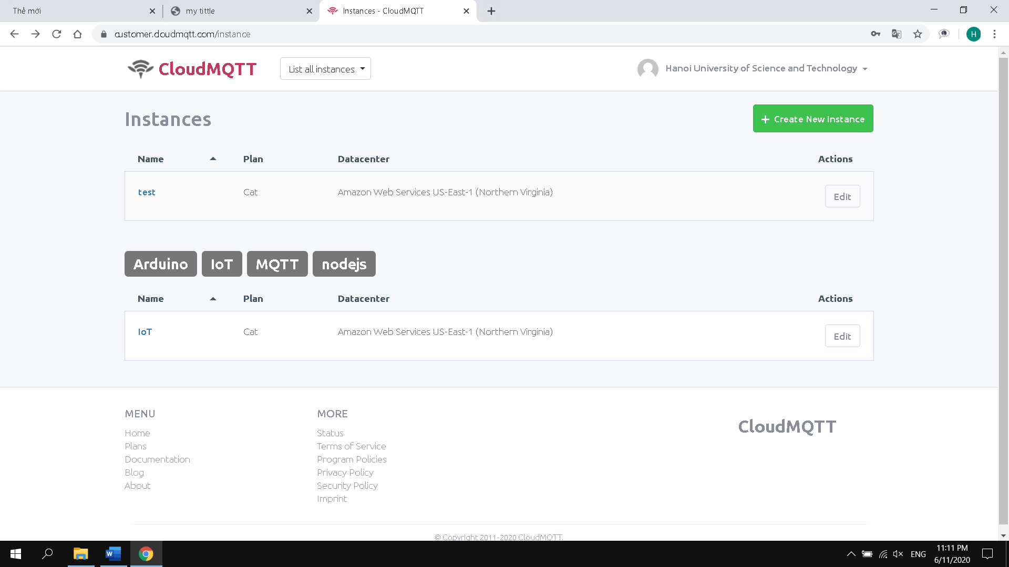

Websocket ui

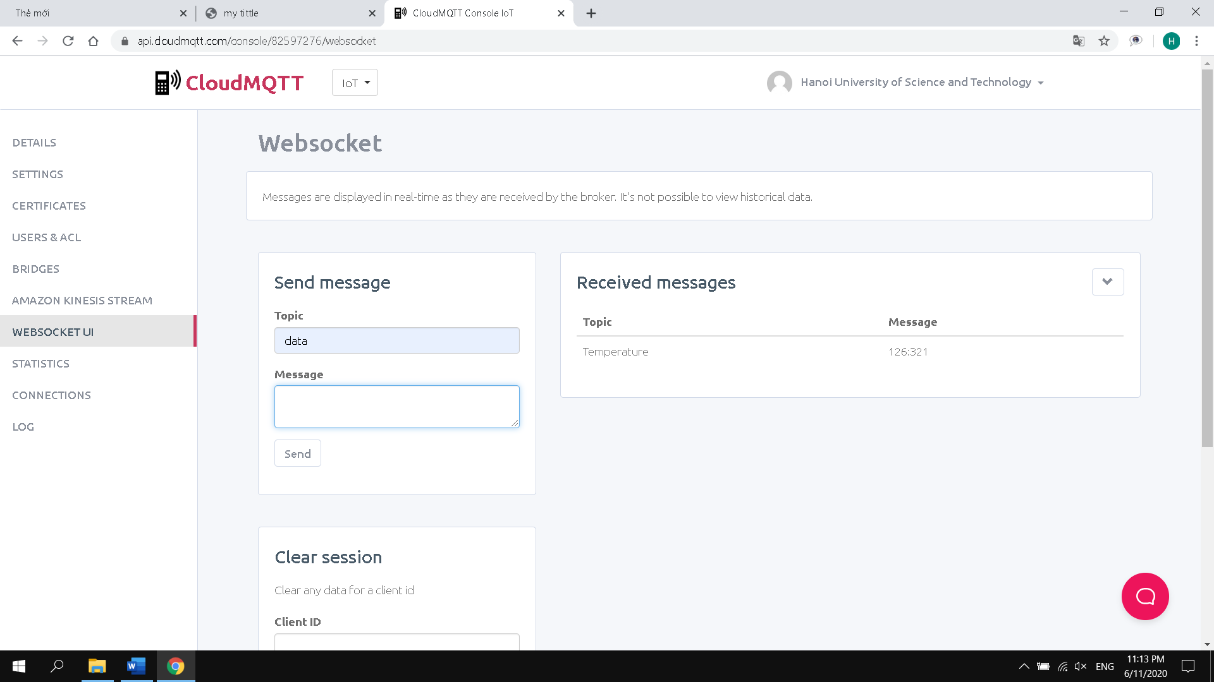

Topic :data

Messange: file text